Months of the year
January - is the first month of the year in the Julian and Gregorian calendars and one of seven months with the length of 31 days. The first day of the month is known as New Year's Day.
February - is the second month of the year .It is the shortest month and the only month with 28/29 days. In February we can also go skiing.
March - is the third month of the year. It is one of seven months that have 31 days long. The weather is usually cold, windy and rainy.
April - is the fourth month of the year . In April we also celebrate Easter. The Easter holiday lasts four days from Good Friday to Easter Monday. I like April, because in this month many animals are born.
May - is the fifth month of the year. We celebrate International Work´s Day in Slovakia. It is the first day of May. We celebrate the Mother’s Day on the 10th May.
June - is the first month of summer. In June it is one of the most popular day for children, the Children’s Day.
July - is the first month of summer holiday. In history children had more holiday then we, but they used it for work.
August - is the second and last month of summer holidays. The weather in August is sunny. People normally wear T- shirts, dresses, flip-flops and swim suits.
September - many children don’t like this month because we have to come back to school, so do I. But it’s my birthday in September.
October - now is October one of my favourite months because my parents will get married. I don’t like the weather in October. It starts to be cold, windy and rainy too.
November - is the third month of autumn. In November we celebrate Halloween. Children meet their friends and they make a Halloween party. Families make their house more scary with some pumpkins.
December - we celebrate Christmas! It is one of the most popular day in year, Jesus comes and he gives presents to children. Before he comes we meet all family and we have family dinner. The next super thing in December is that we have winter holiday.
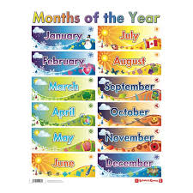
Michaela Bérešová 5.A

M

